📘 Project Documentation

Project Title:

**Real Estate Market Intelligence 📈**

**Submitted By:**

Vedanth Reddy S N

**Domain:**

Data Analytics

**Tools & Technologies Used:**

SQL (MySQL Workbench)

Excel (Pivot Tables, Charts, Dashboard)

Python (Pandas, Mathplotlib , EDA )

**Date:**

October 2025

**Table of Contents**

1. Project Overview
2. Objectives
3. Business Questions
4. Dataset Description
5. Tools & Technologies
6. Methodology / Approach
7. Insights & Findings
8. Dashboard Preview
9. Challenges & Solutions
10. Conclusion

**Project Overview 📊**

The Real Estate Market Intelligence Dashboard is a data-driven analytics project designed to provide actionable insights into the real estate sector. By combining Python, SQL, and Excel, the project analyzes property datasets to identify trends, patterns, and market opportunities. The dashboard serves as a decision-support tool for investors, buyers, and real estate professionals.

**Objectives**

* Build a clear and simple dashboard to show the most important business numbers.
* Make it easy for users to check performance at a glance.
* Show trends and comparisons without needing to look at raw data tables.

**Business Questions**

1. **Average Price By Property Type And Year Built ?**

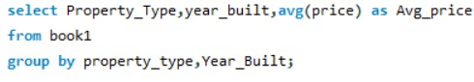**2. TOP 5 Most Expensive Properties By Location ?**

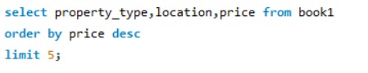

1. **Most expensive property in each location?**

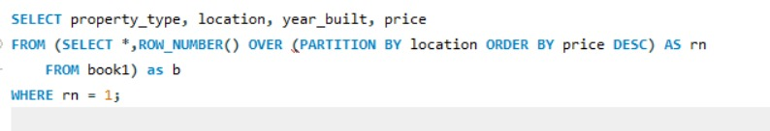

1. **Yearly trend of average prices?**

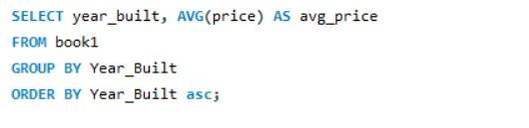

1. **Distribution Of Properties By Buily Year Range?**

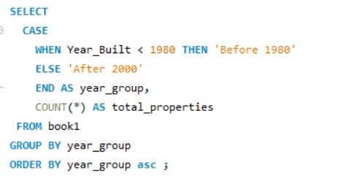

1. **Average Price By Square Feet By Location?**

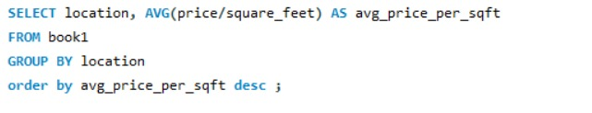

1. **TOP 10 Properties With Avg Price Cost ?**

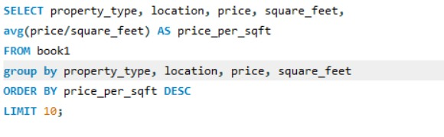

**Dataset Description**

* Source: Kaggle - Real Estate Datasets
* Size: 500 rows, 9 columns

**Key Fields:**

* Property ID: Unique identifier for each property.
* Location: City
* Property Type: Apartment, House, etc.
* Bedrooms: No. of Bedrooms
* Bathrooms: No. of Bathrooms
* Square_feet: Property area in square feet (decimal values, e.g., 2453.7 sq.ft.
* Year_Built: Year when the property was constructed.
* Condition: New, Good, Needs Renovation.
* Prize: Property price (in USD)

**Tools & Technologies**

* Python – Used for data cleaning, preprocessing, and exploratory data analysis (EDA) Libraries: pandas, matplotlib
* SQL (MySQL Workbench) – Used for querying, aggregating, and extracting insights from datasets, Data Handling & Visualization
* Excel – Pivot tables, charts, and for summarizing and visualizing property data
* Matplotlib – For generating charts and plots to visualize price trends, top locations, and property type distribution

Additional Tool

* Jupyter Notebook – For Python code development and interactive analysis.

**Methodology / Approach**

My project followed a structured workflow:

* Data Collection: Obtained datasets from Kaggle.
* Data Cleaning & Preprocessing: Imputed missing numeric values using mean/median. Removed duplicates and irrelevant records.
* Exploratory Data Analysis (EDA): Analyzed property distribution by location, price, and type. Identified patterns, outliers, and trends.
* Pivot Table Analysis (Excel): Created 10 pivot tables summarizing top locations, price trends, and decade-wise growth.
* SQL Analytics (MySQL Workbench): Extracted top properties, average prices, and location-wise statistics.
* Data Visualization: Developed charts using matplotlib for price trends, property types, and top locations.
* Dashboard Development: Integrated pivot tables and visualizations into a structured dashboard for actionable insights.

**Insights & Findings**

* The dashboard gives a quick summary of key metrics like sales, revenue, or growth.
* Charts make it easier to compare different regions, products, or time periods.Trends can be spotted quickly
* It also helps to identify which areas are doing well and which need attention.
* Instead of going through long reports, the visuals make the big picture clear in seconds.

**Challenges & Solutions**

**Challenge 1:** Getting all data into one place and keeping it updated.

**Solution:** Connect the dashboard to clean and updated data sources.

**Challenge 2:** Making sure the charts are easy to read and not overcrowded.

**Solution:** Use proper data cleaning before adding it to visuals.

**Challenge 3:** Designing the layout so it looks professional but simple.

**Solution:** Keep the design simple: right colors, labels, and not too much clutter.

**Challenge 4:** Handling cases where new KPIs or data might be added in the future.

**Solution:** Add filters or slicers so users can explore data in more detail.

**Conclusion**

* The Real estate market intelligence dashboard shows how data can be turned into easy-to-understand visuals.
* It helps users see performance, trends, and problem areas without needing to dive into spreadsheets.
* This project highlights skills in data analysis, visualization, and presentation.